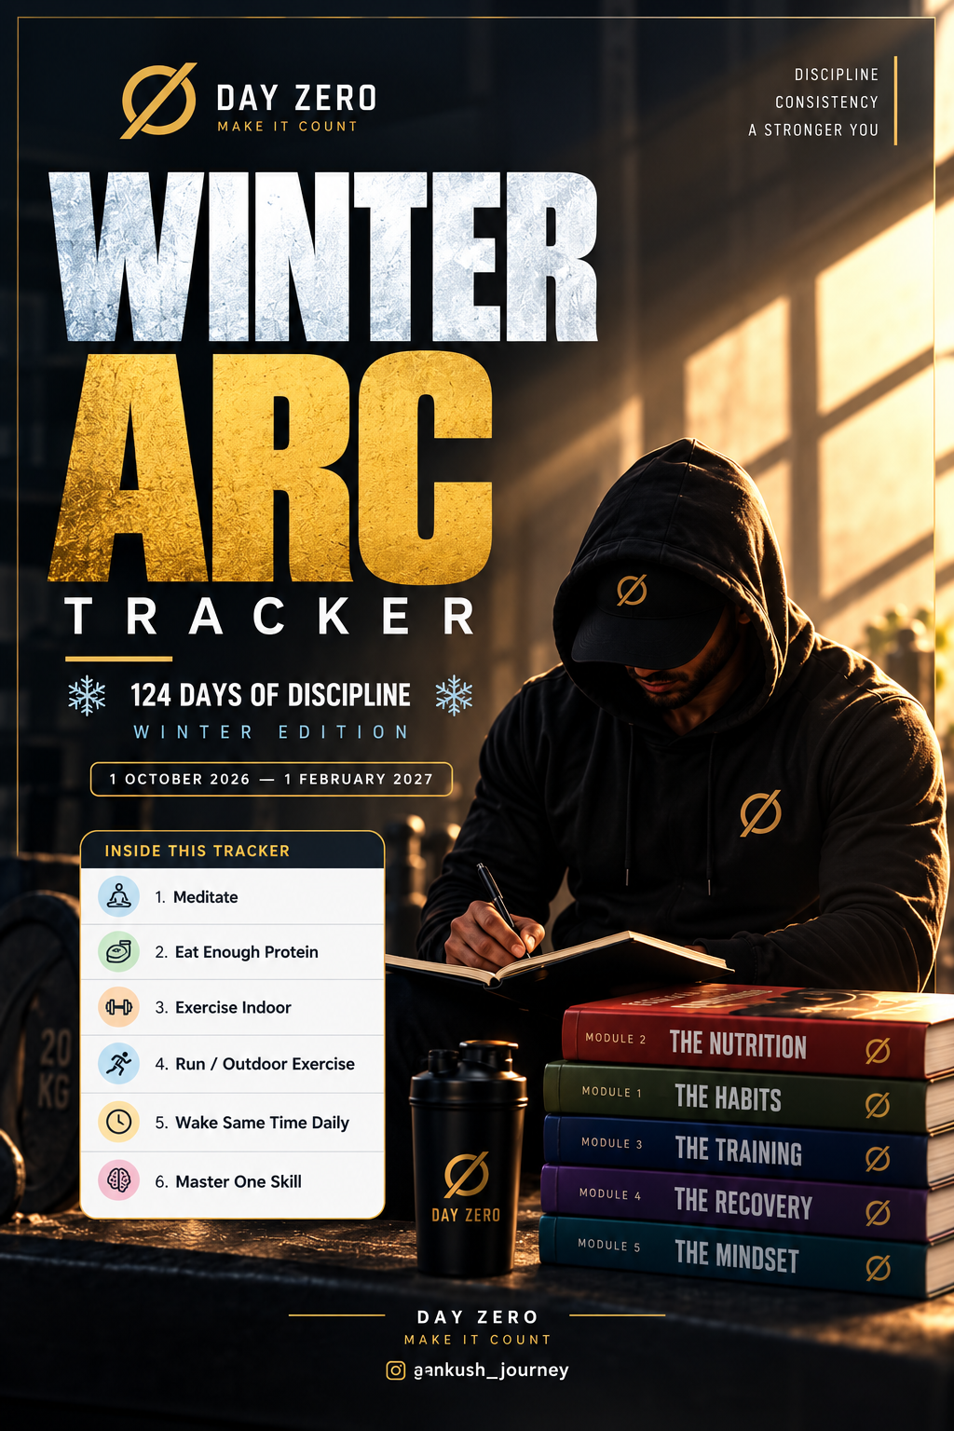
❄ WINTER ARC ❄
1 Oct – 15 Oct 2026
Ankush's DAILY NON-NEGOTIABLES
 |  | 1  Thu | 2  Fri | 3  Sat | 4  Sun | 5  Mon | 6  Tue | 7  Wed | 8  Thu | 9  Fri | 10  Sat | 11  Sun | 12  Mon | 13  Tue | 14  Wed | 15  Thu
 | Meditate
 | Eat Enough Protein
 | Exercise Indoor
 | Run / Outdoor Exercise
 | Wake Same Time Daily
 | Master One Skill
 | WEEK 1–2 OF 16 · PAGE 1 OF 8
“
The winter doesn't ask if you're ready. It just arrives. So do the work anyway.
— DAY ZERO
@ankush_journey

❄ WINTER ARC ❄
16 Oct – 31 Oct 2026
Ankush's DAILY NON-NEGOTIABLES
 |  | 16  Fri | 17  Sat | 18  Sun | 19  Mon | 20  Tue | 21  Wed | 22  Thu | 23  Fri | 24  Sat | 25  Sun | 26  Mon | 27  Tue | 28  Wed | 29  Thu | 30  Fri | 31  Sat
 | Meditate
 | Eat Enough Protein
 | Exercise Indoor
 | Run / Outdoor Exercise
 | Wake Same Time Daily
 | Master One Skill
 | WEEK 3–4 OF 16 · PAGE 2 OF 8
“
Discipline is choosing between what you want now and what you want most.
— DAY ZERO
@ankush_journey

❄ WINTER ARC ❄
1 Nov – 15 Nov 2026
Ankush's DAILY NON-NEGOTIABLES
 |  | 1  Sun | 2  Mon | 3  Tue | 4  Wed | 5  Thu | 6  Fri | 7  Sat | 8  Sun | 9  Mon | 10  Tue | 11  Wed | 12  Thu | 13  Fri | 14  Sat | 15  Sun
 | Meditate
 | Eat Enough Protein
 | Exercise Indoor
 | Run / Outdoor Exercise
 | Wake Same Time Daily
 | Master One Skill
 | WEEK 5–6 OF 16 · PAGE 3 OF 8
“
No one becomes disciplined in a day. But every day adds up to become undeniable.
— DAY ZERO
@ankush_journey

❄ WINTER ARC ❄
16 Nov – 30 Nov 2026
Ankush's DAILY NON-NEGOTIABLES
 |  | 16  Mon | 17  Tue | 18  Wed | 19  Thu | 20  Fri | 21  Sat | 22  Sun | 23  Mon | 24  Tue | 25  Wed | 26  Thu | 27  Fri | 28  Sat | 29  Sun | 30  Mon
 | Meditate
 | Eat Enough Protein
 | Exercise Indoor
 | Run / Outdoor Exercise
 | Wake Same Time Daily
 | Master One Skill
 | WEEK 7–8 OF 16 · PAGE 4 OF 8
“
The cold doesn’t build character. What you do in spite of it does.
— DAY ZERO
@ankush_journey

❄ WINTER ARC ❄
1 Dec – 15 Dec 2026
Ankush's DAILY NON-NEGOTIABLES
 |  | 1  Tue | 2  Wed | 3  Thu | 4  Fri | 5  Sat | 6  Sun | 7  Mon | 8  Tue | 9  Wed | 10  Thu | 11  Fri | 12  Sat | 13  Sun | 14  Mon | 15  Tue
 | Meditate
 | Eat Enough Protein
 | Exercise Indoor
 | Run / Outdoor Exercise
 | Wake Same Time Daily
 | Master One Skill
 | WEEK 9–10 OF 16 · PAGE 5 OF 8
“
You don’t rise to the level of your goals. You fall to the level of your systems.
— DAY ZERO
@ankush_journey

❄ WINTER ARC ❄
16 Dec – 31 Dec 2026
Ankush's DAILY NON-NEGOTIABLES
 |  | 16  Wed | 17  Thu | 18  Fri | 19  Sat | 20  Sun | 21  Mon | 22  Tue | 23  Wed | 24  Thu | 25  Fri | 26  Sat | 27  Sun | 28  Mon | 29  Tue | 30  Wed | 31  Thu
 | Meditate
 | Eat Enough Protein
 | Exercise Indoor
 | Run / Outdoor Exercise
 | Wake Same Time Daily
 | Master One Skill
 | WEEK 11–12 OF 16 · PAGE 6 OF 8
“
Small actions, repeated daily, are how physiques and empires are both built.
— DAY ZERO
@ankush_journey

❄ WINTER ARC ❄
1 Jan – 15 Jan 2027
Ankush's DAILY NON-NEGOTIABLES
 |  | 1  Fri | 2  Sat | 3  Sun | 4  Mon | 5  Tue | 6  Wed | 7  Thu | 8  Fri | 9  Sat | 10  Sun | 11  Mon | 12  Tue | 13  Wed | 14  Thu | 15  Fri
 | Meditate
 | Eat Enough Protein
 | Exercise Indoor
 | Run / Outdoor Exercise
 | Wake Same Time Daily
 | Master One Skill
 | WEEK 13–14 OF 16 · PAGE 7 OF 8
“
The arc isn’t about one perfect day. It’s about never missing two in a row.
— DAY ZERO
@ankush_journey

❄ WINTER ARC ❄
16 Jan – 1 Feb 2027
Ankush's DAILY NON-NEGOTIABLES
 |  | 16  Sat | 17  Sun | 18  Mon | 19  Tue | 20  Wed | 21  Thu | 22  Fri | 23  Sat | 24  Sun | 25  Mon | 26  Tue | 27  Wed | 28  Thu | 29  Fri | 30  Sat | 31  Sun | 1  Mon
 | Meditate
 | Eat Enough Protein
 | Exercise Indoor
 | Run / Outdoor Exercise
 | Wake Same Time Daily
 | Master One Skill
 | WEEK 15–16 OF 16 · PAGE 8 OF 8
“
By February, you won’t recognize the person who started this in October.
— DAY ZERO
@ankush_journey

